**Ideation Phase**

**Empathize & Discover**

|  |  |
| --- | --- |
| Date | 19 September 2022 |
| Team ID | PNT2022TMID43957 |
| Project Name | PLASMA DONOR APPLICATION |
| Maximum Marks | 4 Marks |

**Empathy Map Canvas:**

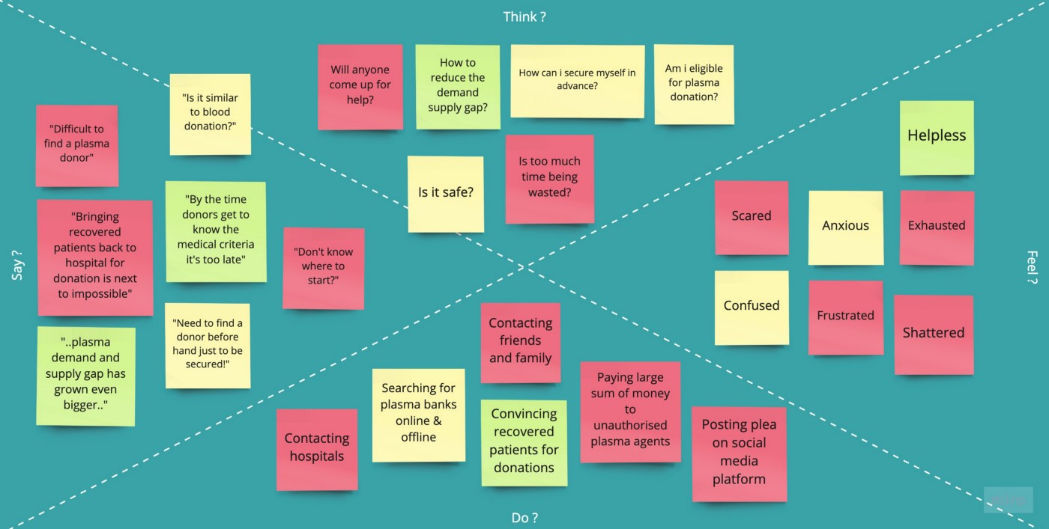

THINK :

* Will any one came for help
* How to reduce the demand supply
* Am i eligible for plasma donor
* It is safe or not

FEED :

* Helpless
* Exhausted
* Confused
* Scared

SAY :

* “Difficult To Find Plasma Donor ”
* “It Is Similar To Blood Donation”
* “Need To Find A Donor Before Hand Just To Be Secured”
* “Don’t Know Where To Start”

DO ? :

* Contacting Friends And Family
* Contacting Hospitals
* Searching For Banks Online And Offline
* Posting Through Social Media